Azure Site Recovery

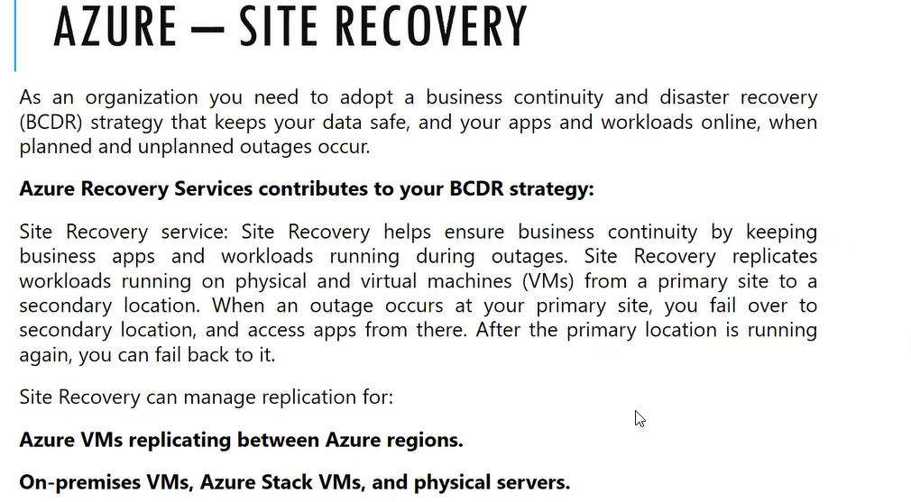

If our infrastructure is completely on Azure, then we can keep site recovery replication from Azure to Azure

From on premises to Azure we can kept replication

They will use the combination of Backup and Recovery site during the practical scenario

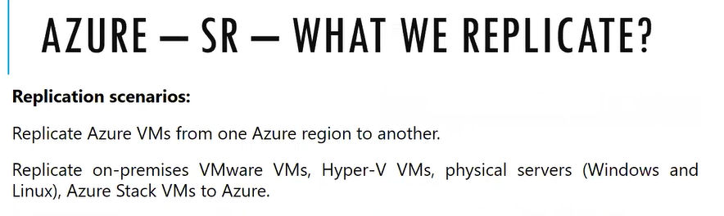

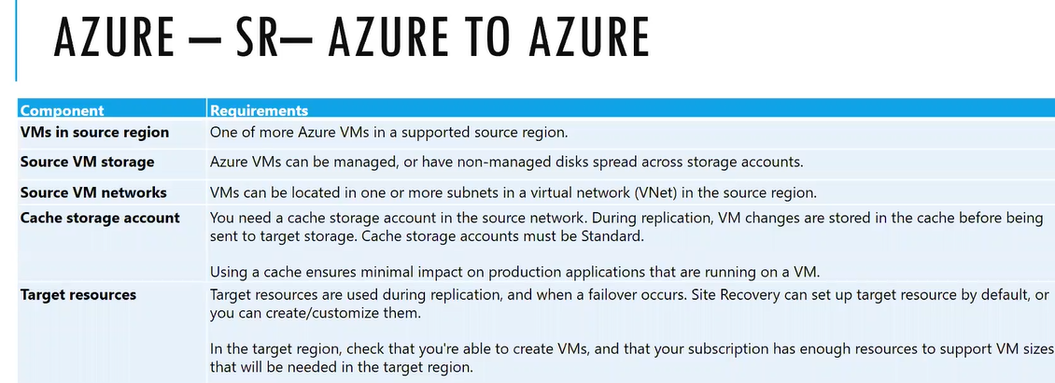

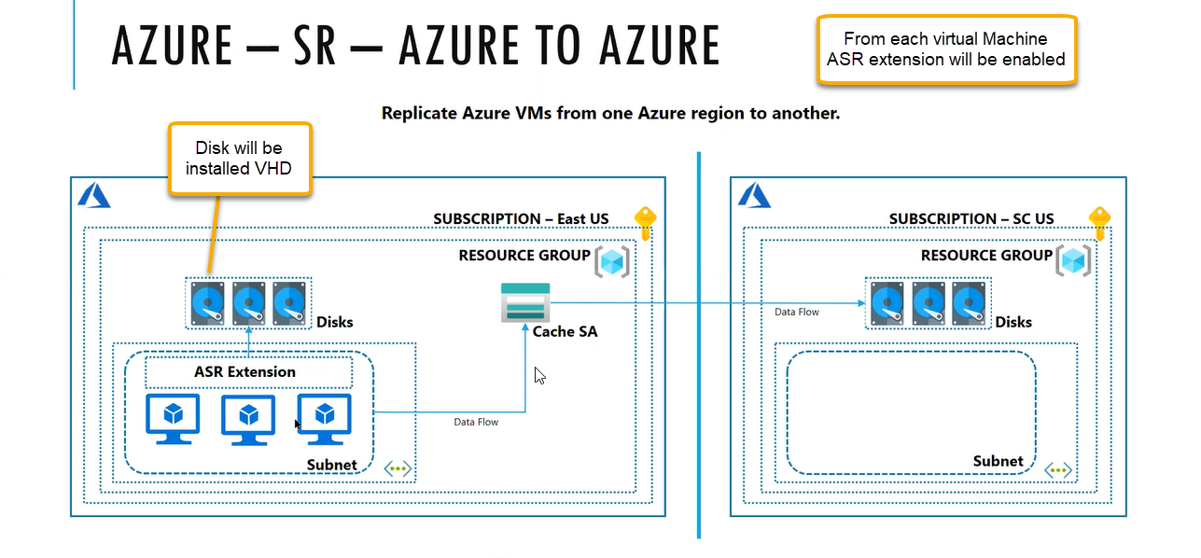

Using the metadata if primary region is destroyed, we can use the secondary region instantly we can use the second VM

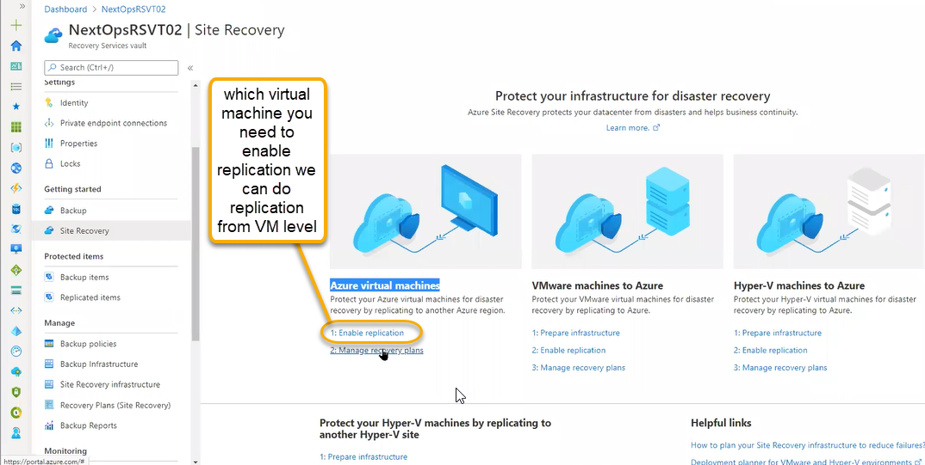

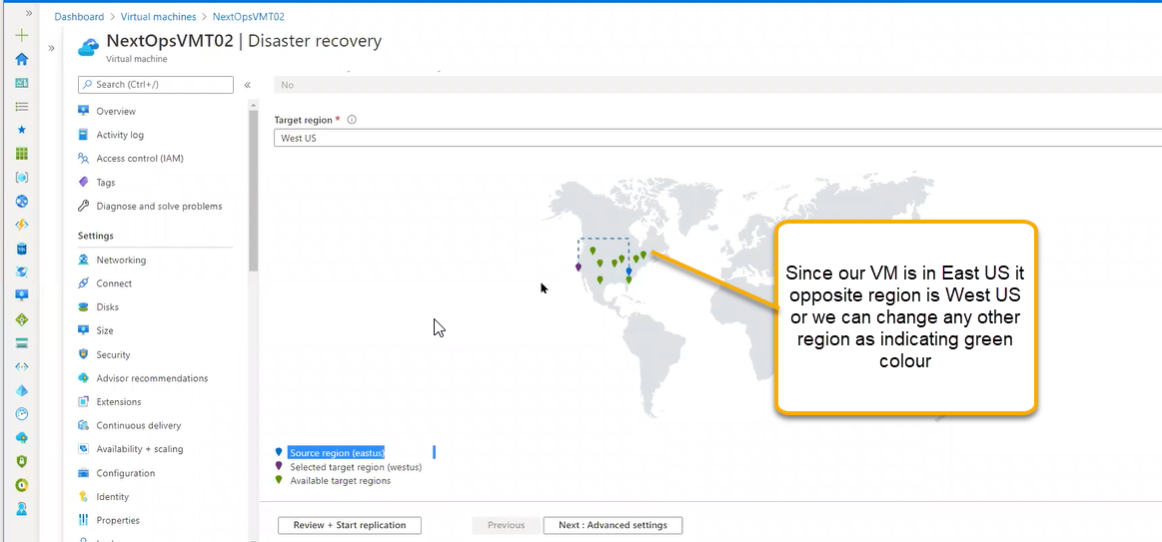

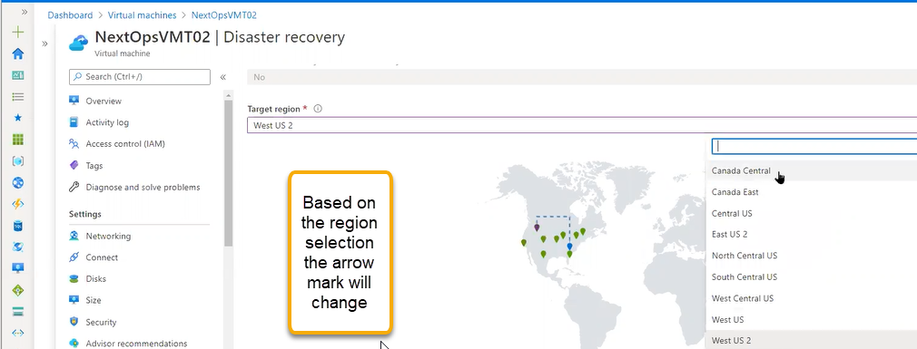

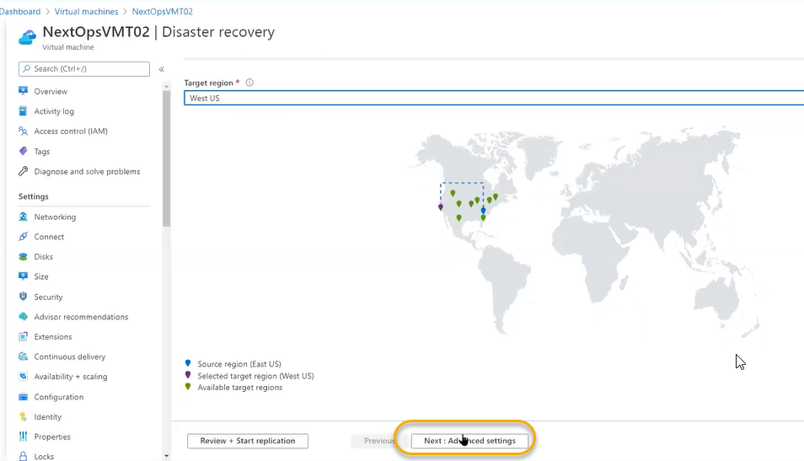

Our deployment completely is EAST US and recovery service vault is also on east us so protection is not enabled/ Much protection for that we need to create the another service vault with different region

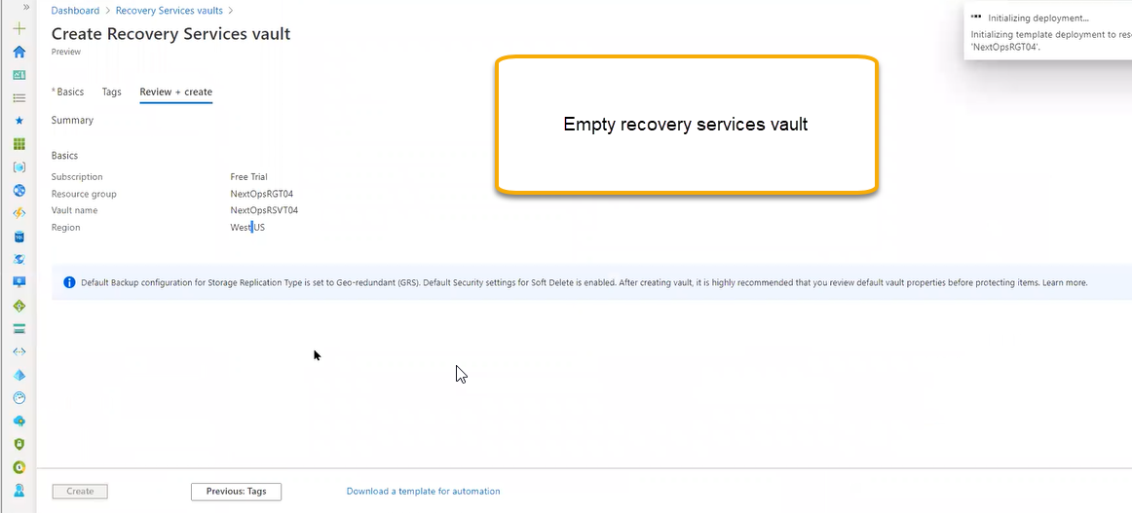

Now WEST US will be destination and source will be EAST US. Go to Site Recovery

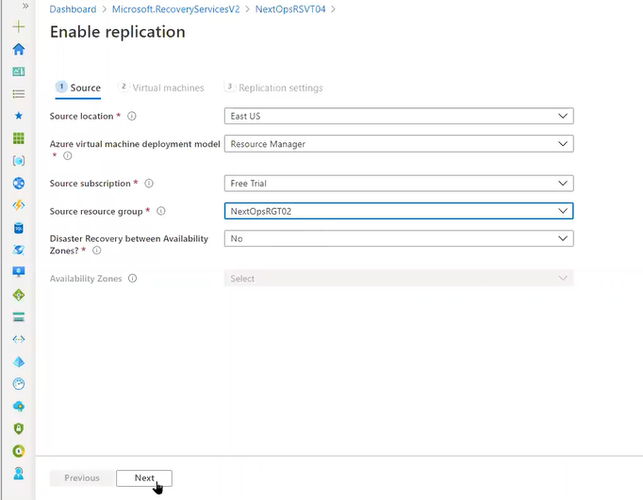

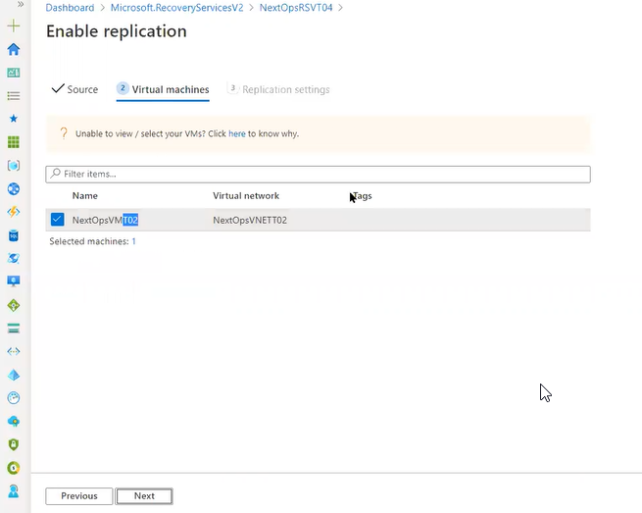

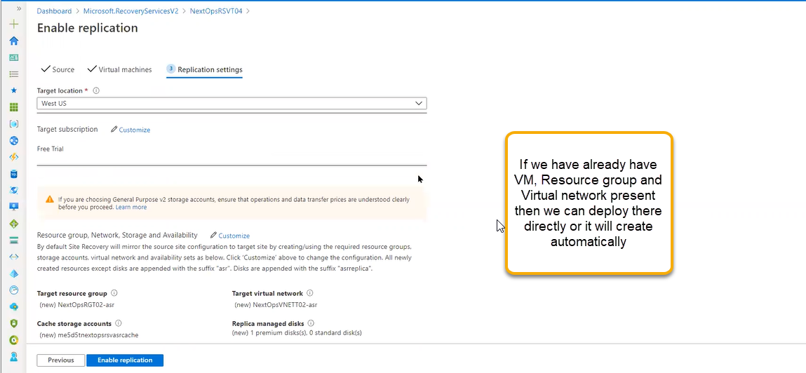

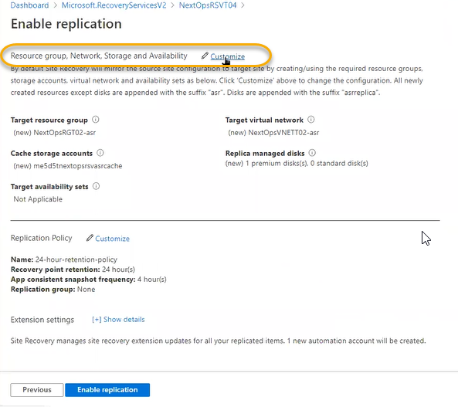

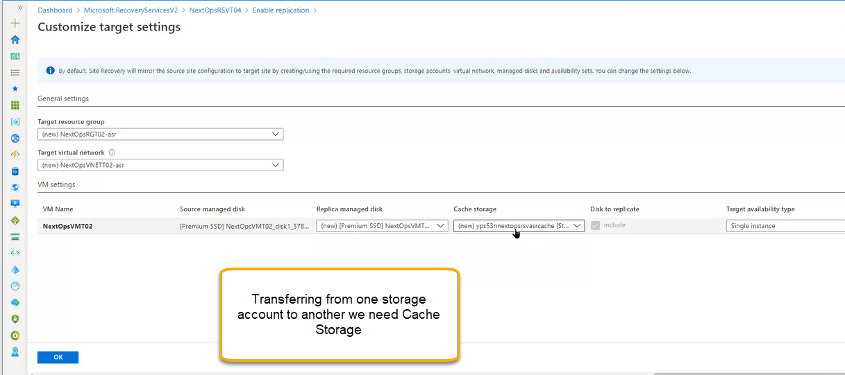

If you are attaching multiple instance then we need to create the Replication Policy

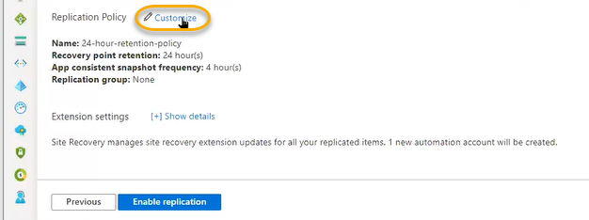

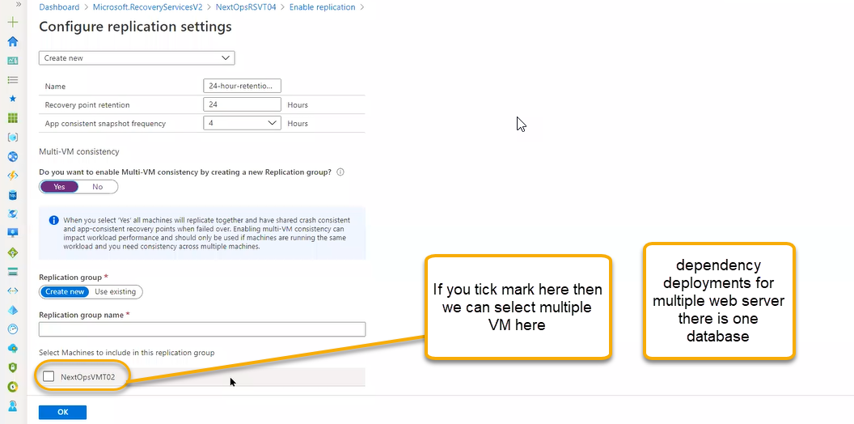

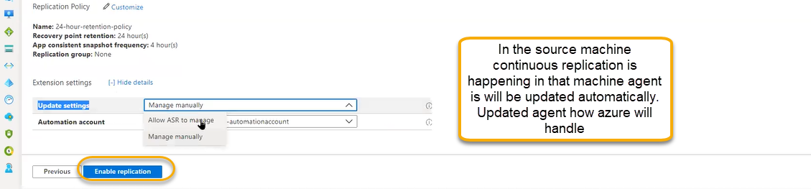

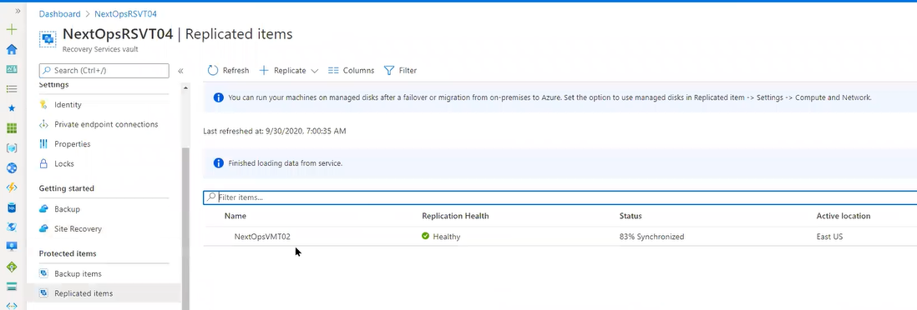

Click on the VMT02

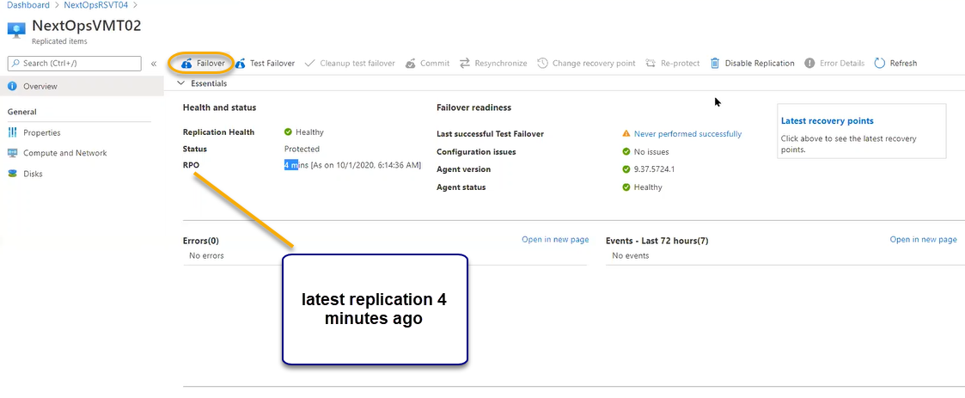

Click on the latest recovery point we can see two snapshots one is app consistent and second is crash consistent snapshot. If you take the disk from latest crash consistent and will do recovery, machine will be rebooted and machine will be normally started. O.S will be normally started. App-consistent if you are taking the snapshot and at that time any application is running like sql, along that O.S that services will also start.

Scroll down we can see the infrastructure view if you click on the test failover simulation will run whether that VM is successfully running on West region

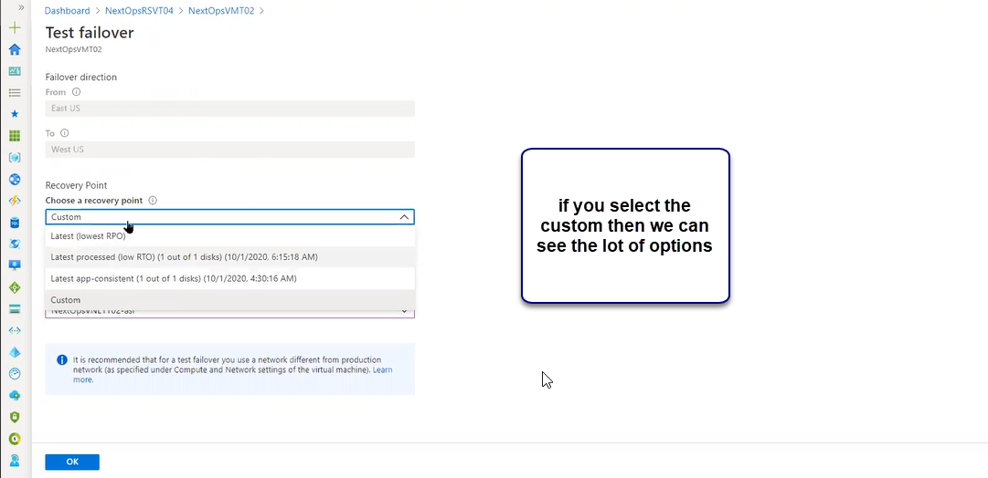

So that you can pick the latest disk

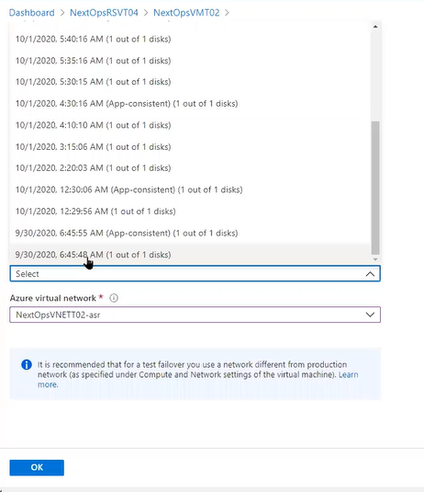

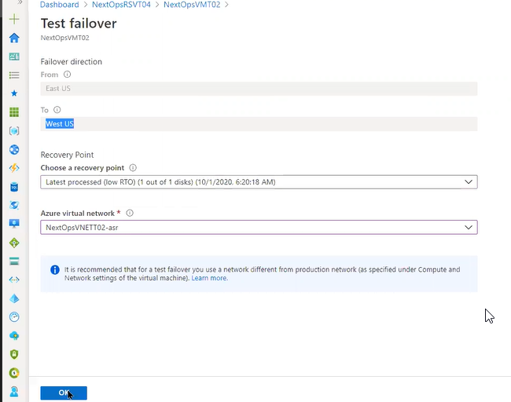

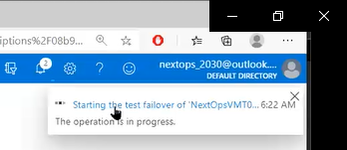

To test the compability we will do test failover

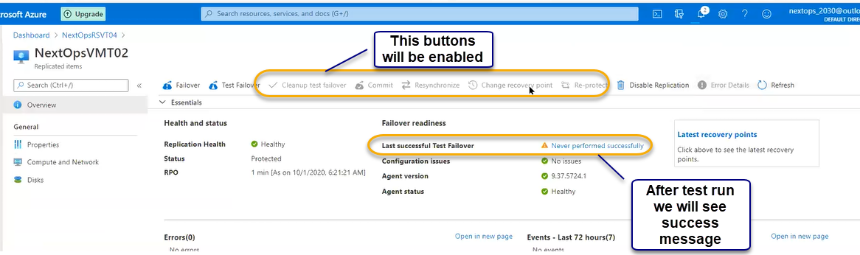

If you want to intentionally fail over then only destination is running, and source will be stooped

Initial replication resources

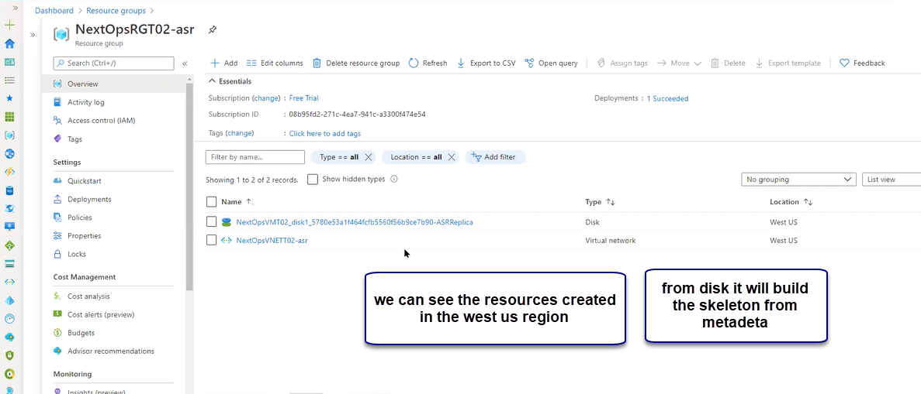

After test failover

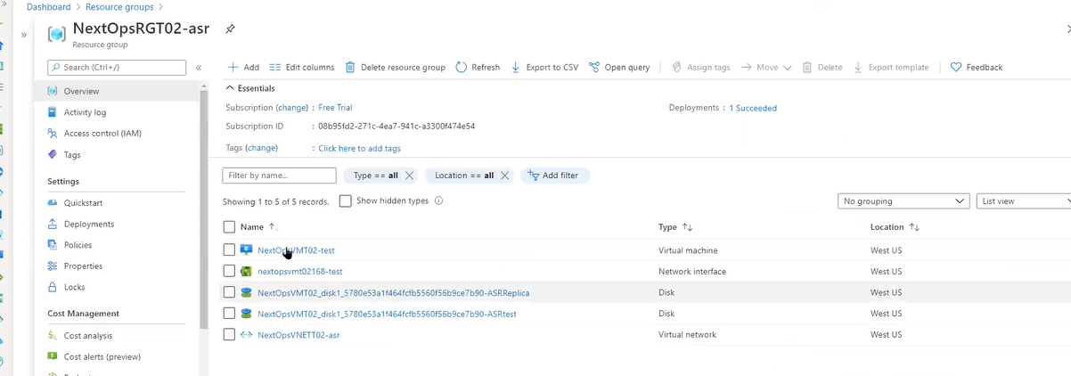

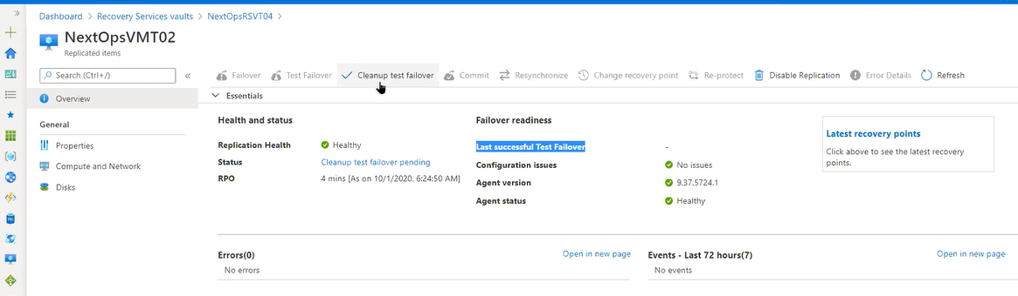

Click on the cleanup test failover

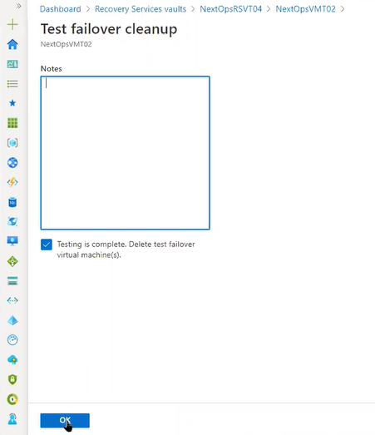

And in the replication resource it will rollback to original ones



If you are doing the failover then it will ask the option which recovery point you will choose and you can choose the latest recovery point and you select the yesterday’s recovery point and Commit at that particular point infrastructure will be runed. And we cannot select remaining recovery points

For Test failover there are multiple recovery points available for all the recovery points we can do test failover which is the best recover point we can do commit at that point after commit the change recovery point is disabled

If there are any errors then we can select the option as Resynchronize and we can do it. If you do want replication then we can select the option as Disable Protection and if you select the Re protect then again we can start protection process

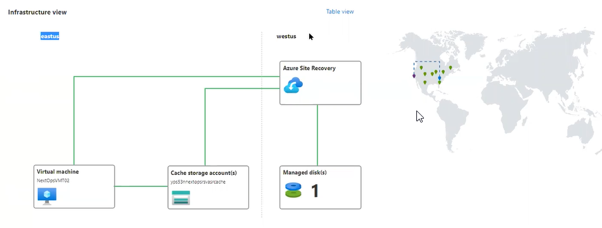

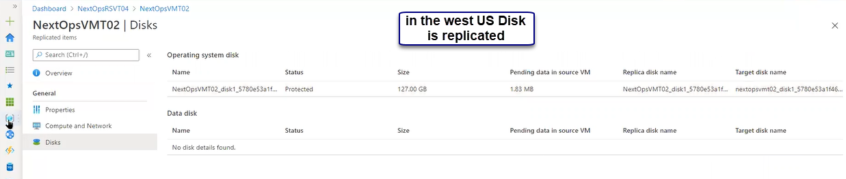

VM ware machines to Azure

We need to site recovery infrastructure > Configuration server > From VM ware /physical server to azure replicate there will be three components mainly configuration server after it got installed inside, we have processor server, master server targets this two will be installed. Azure will use this and replicate the VM infrastructure to Azure. Main replication data is configuration server.

Azure recovery deployment planner

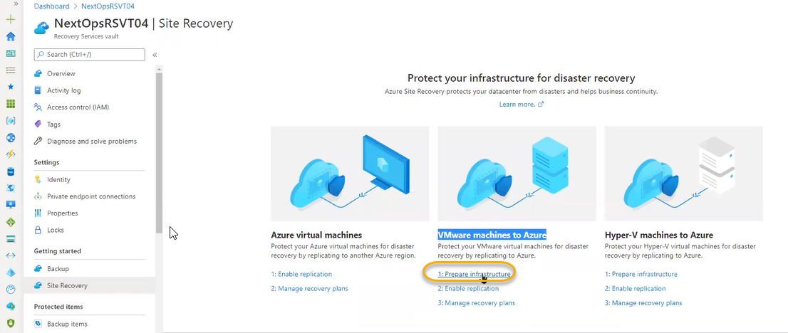

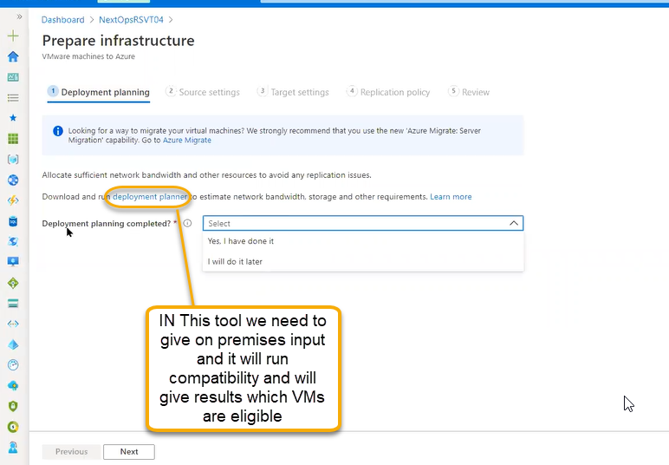

It will start downloading it

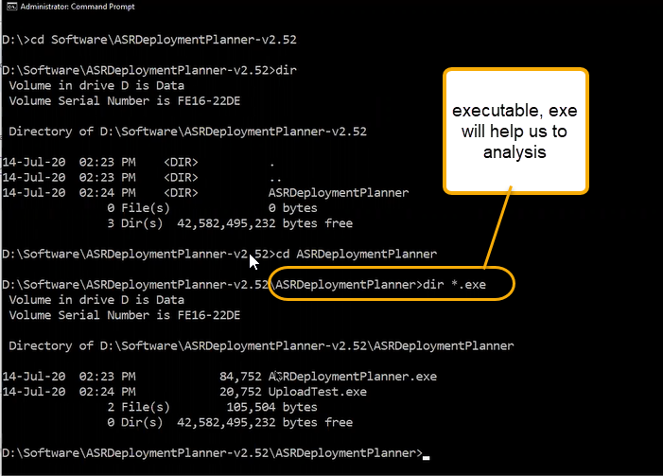

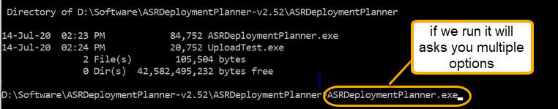

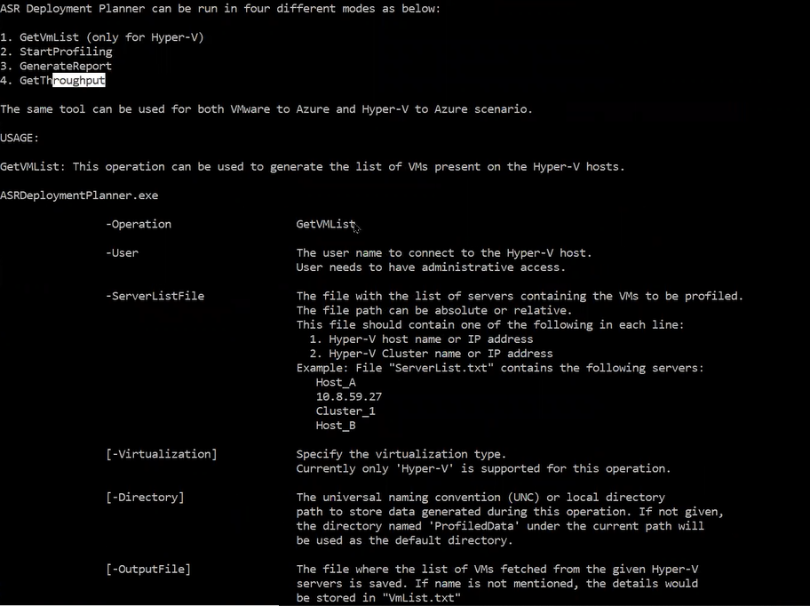

Get VM list: Hyper V related credentials will ask.

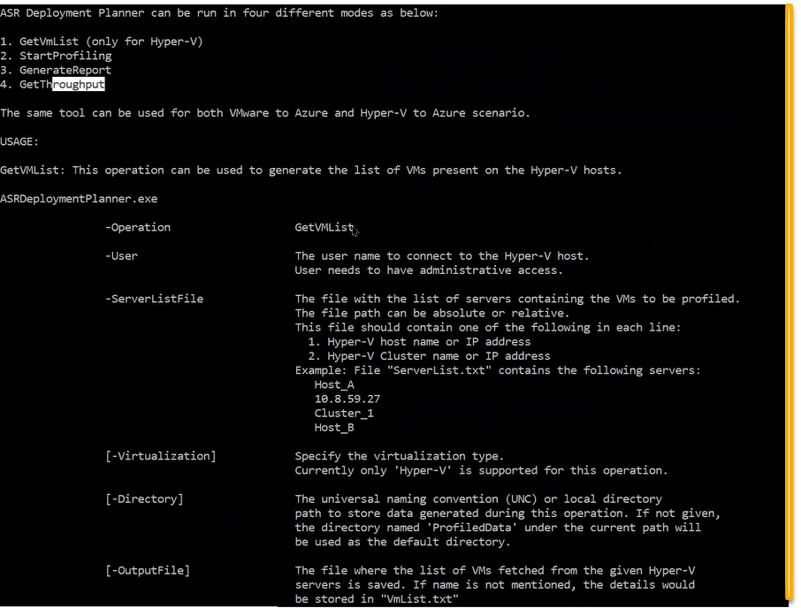

We need to enter the host I.p

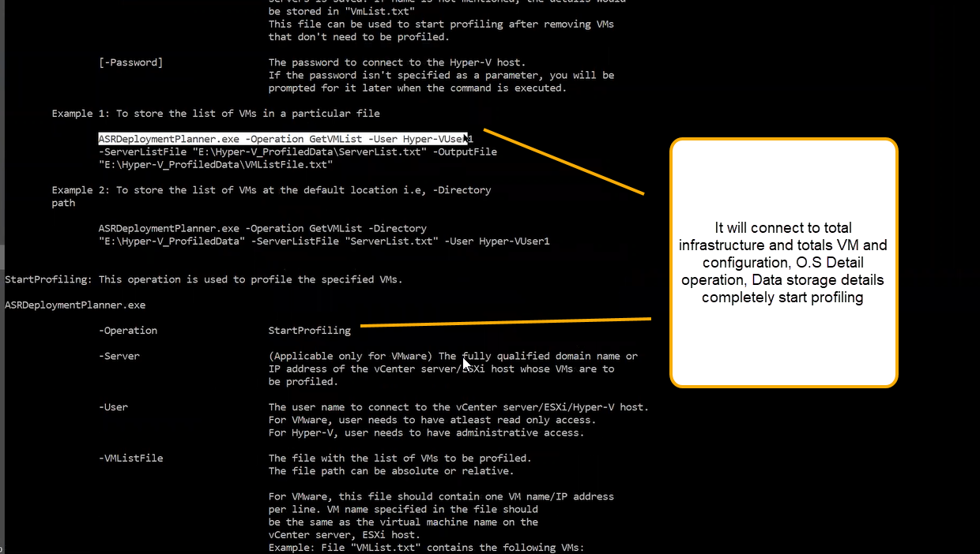

That profiling we can see in the html report below is the example from internet

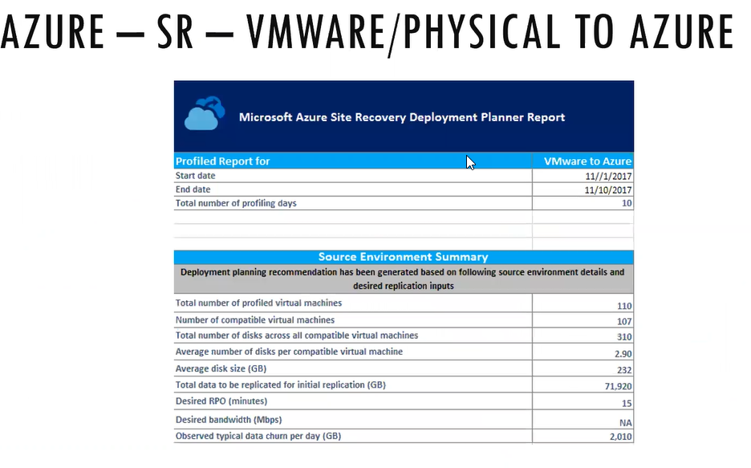

According to report we need to plan the bandwidth storage requirements

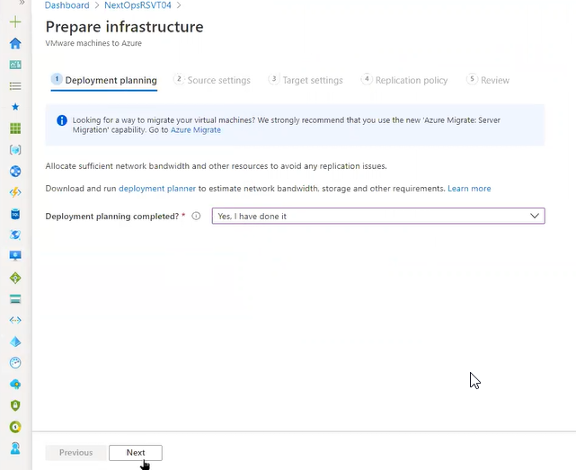

For VM ware infrastructure there is a specific configuration is there that is called server component. That is downloadable software

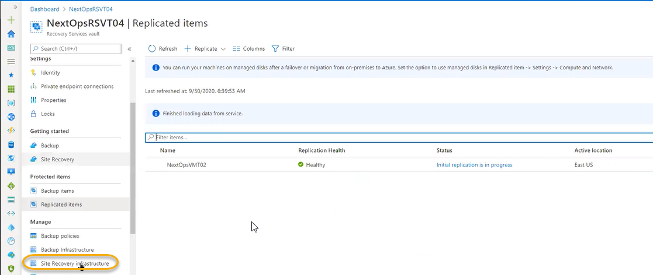

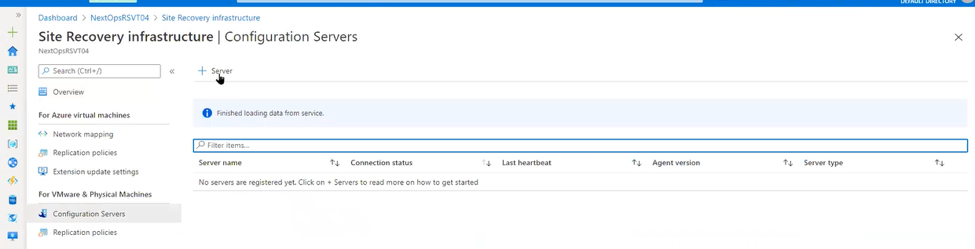

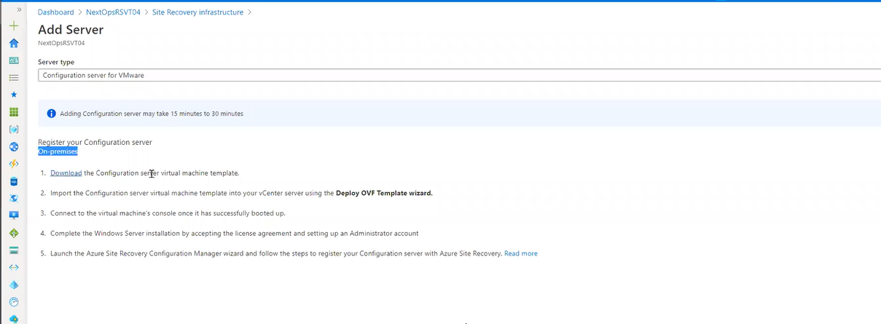

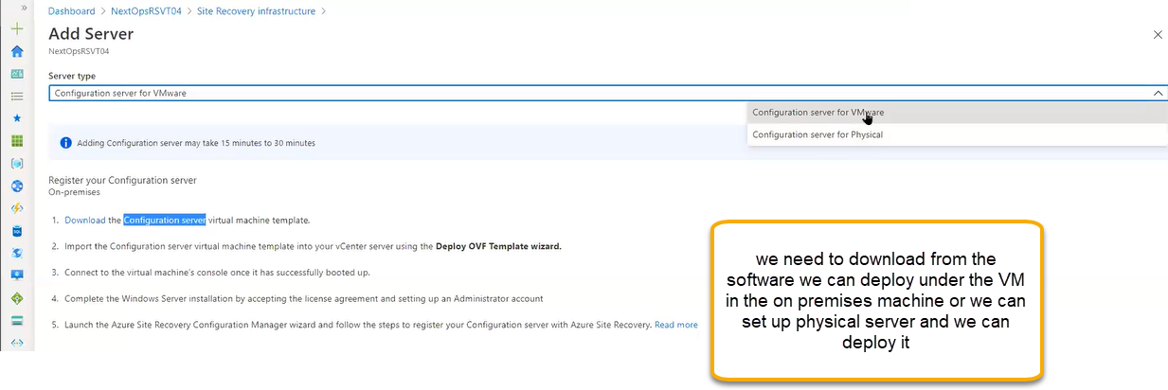

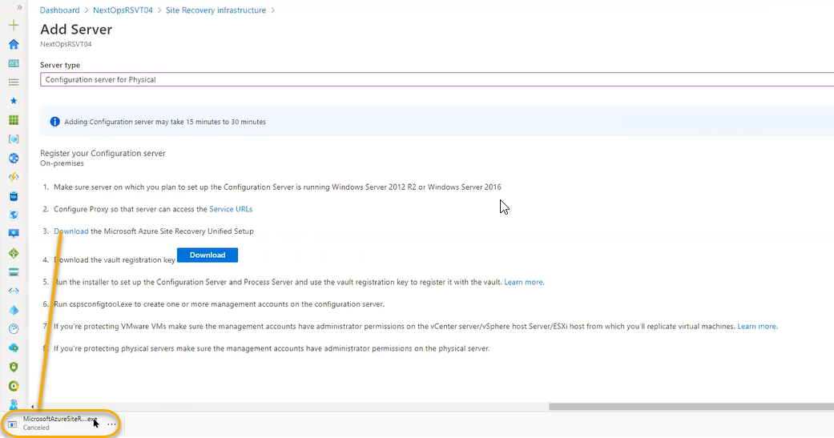

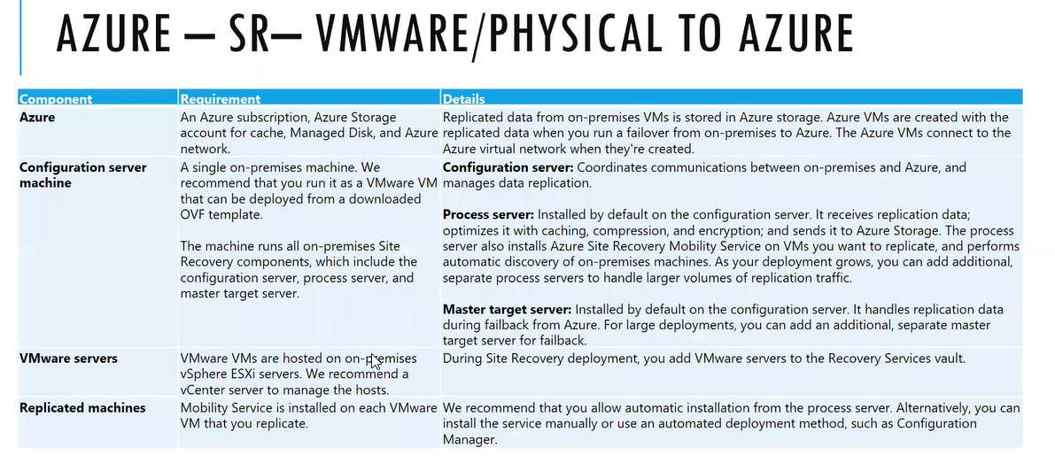

Process server is the key server

Master target server is optional one

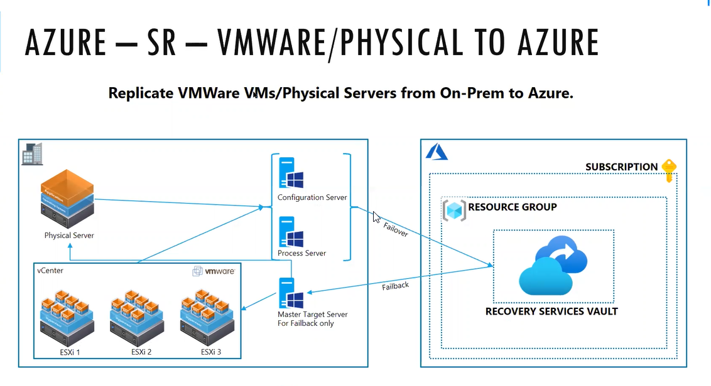

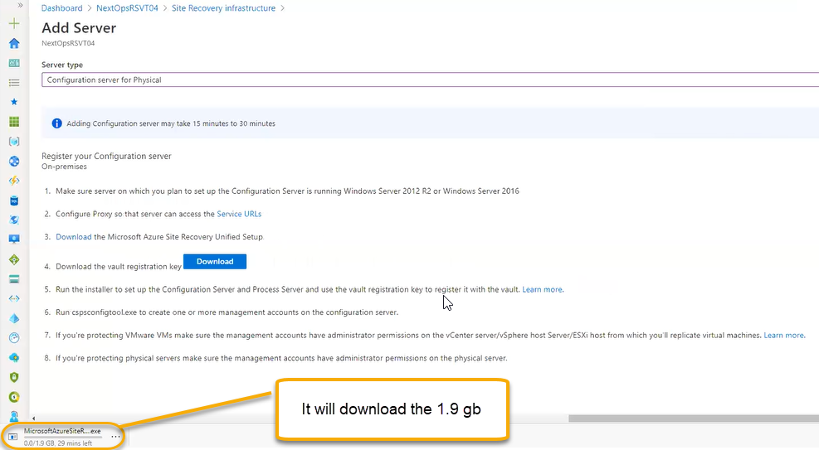

After installing we will see site recovering options

In system settings

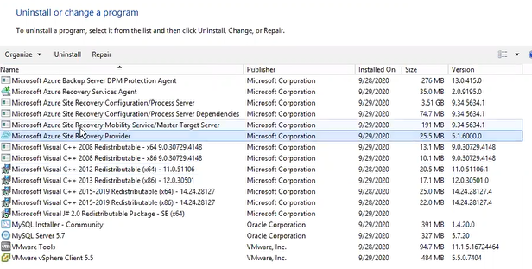

We will see the two short cuts and file we need for vault

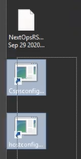

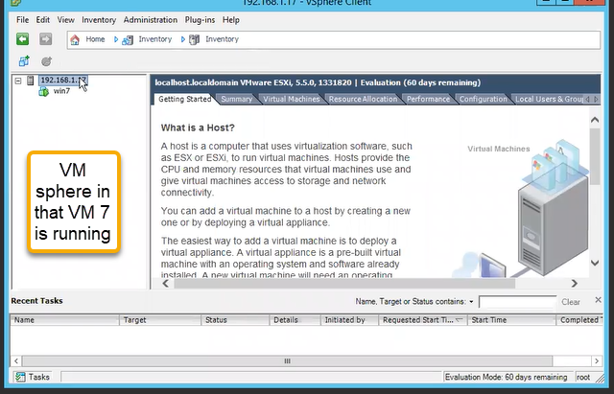

Using the site recovery server in the on premises this VM ware infrastructure machines we need to connect to Azure

1. We need to dedicate the windows machine and we need to download the file and if you install it in one server that will act as broker for the replication from onpremises to Azure

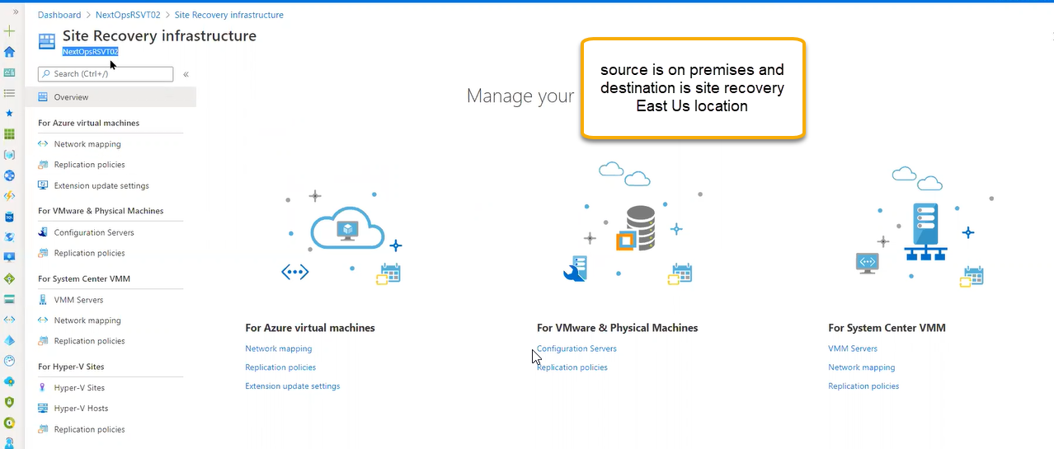

After installing, set up and entering the vault credentials in the on premises we will see the connection in Azure

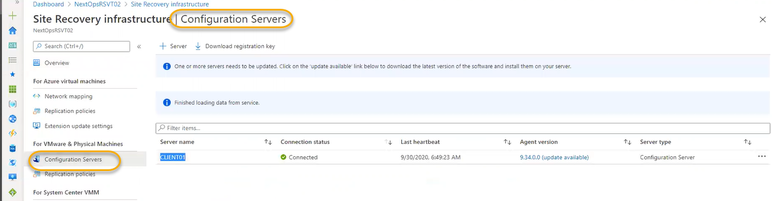

If you click on the server we will see the below info

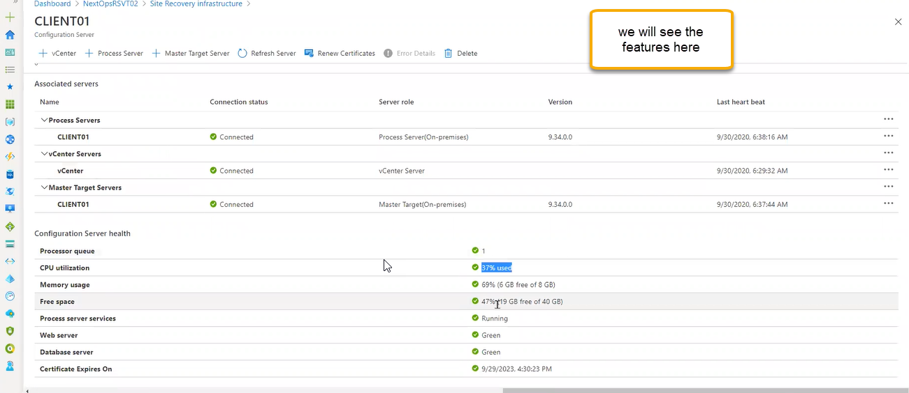

From configuration server VM migration to physical infrastructure click on the + Vcenter as shown above screenshot so that it will add connection to back server

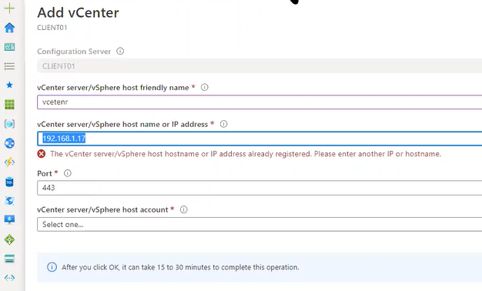

If you select the vCenter then it will ask the credentials which we can fetch from below location

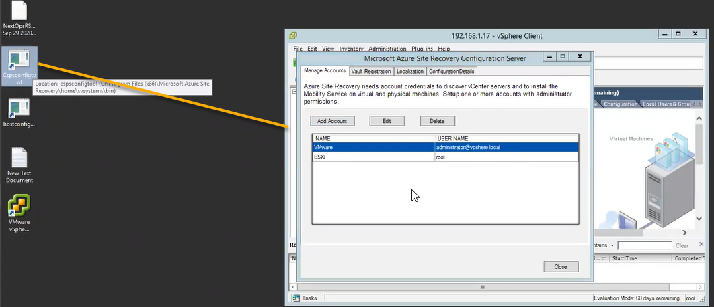

It will execute back on configuration tool and it will see connectivity and Vm ware infrastructure will be added

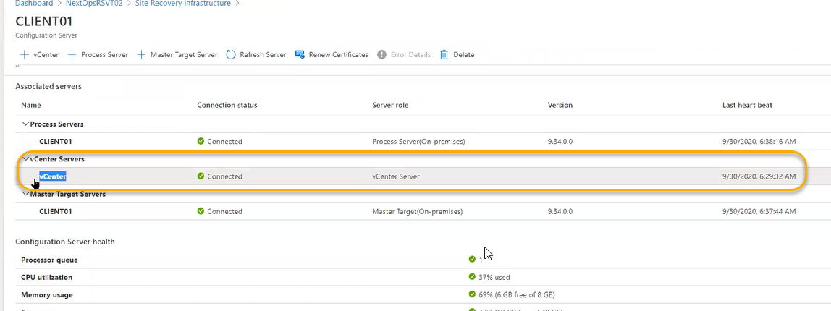

To migrate the VM machine

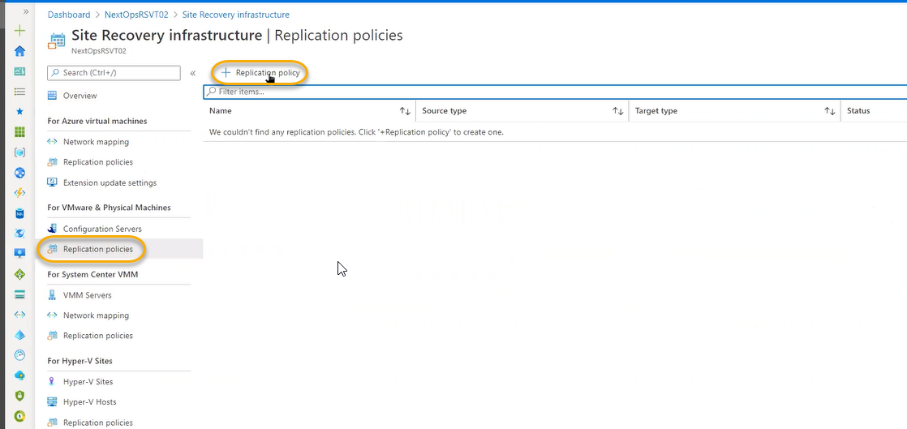

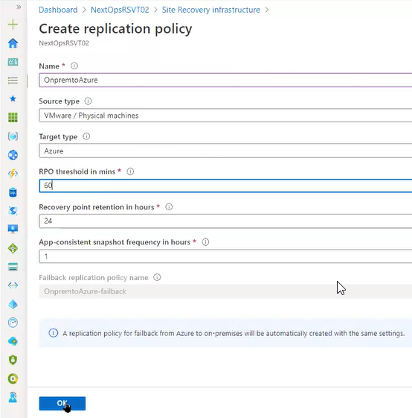

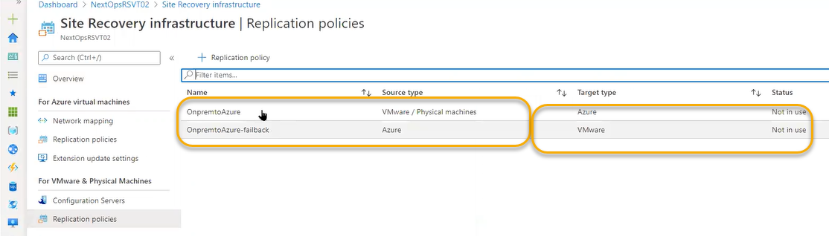

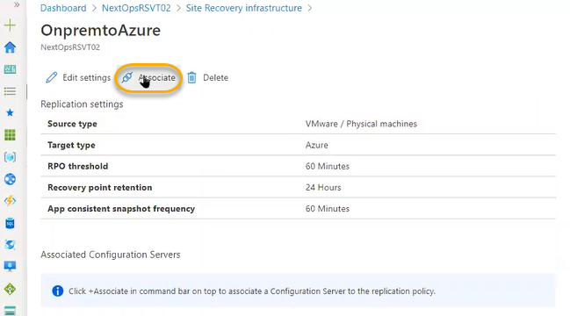

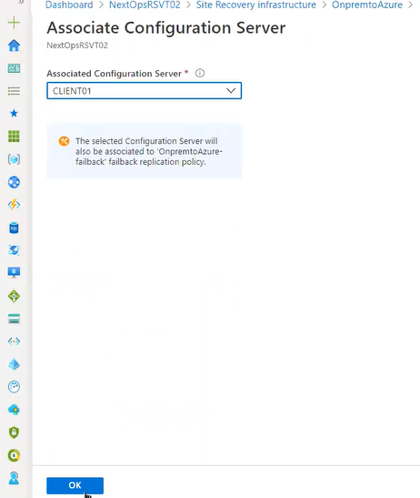

On this processing agent server will push ( ASR Agents) will be handle and do data replication, optimization and do every thing

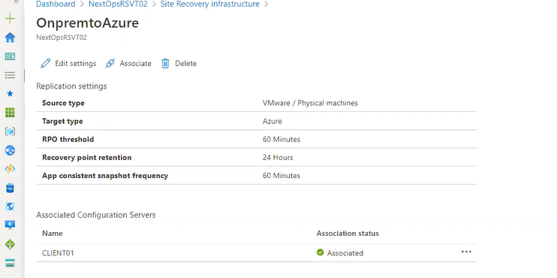

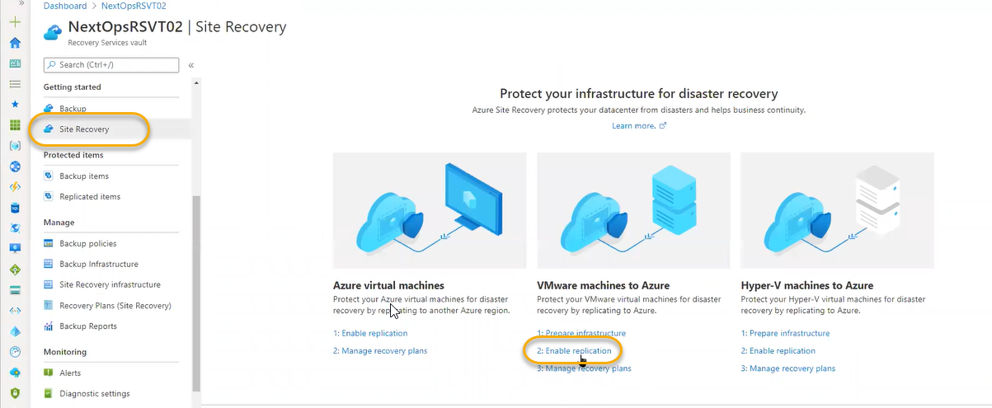

OR

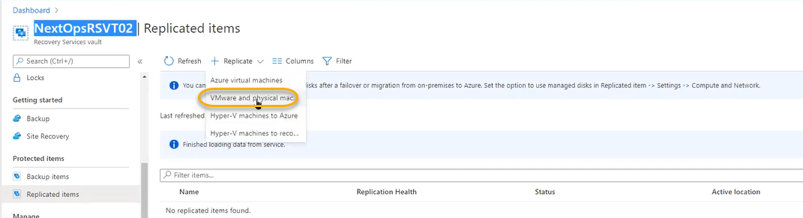

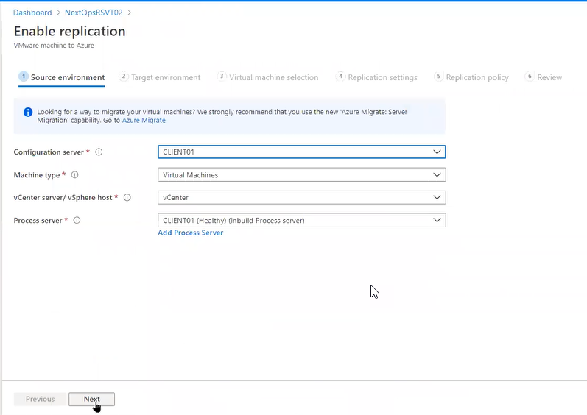

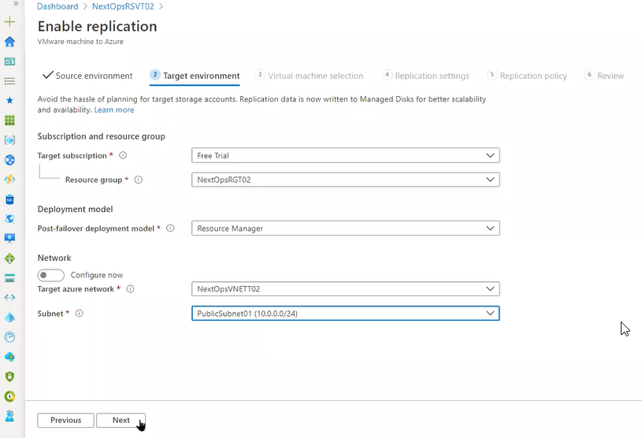

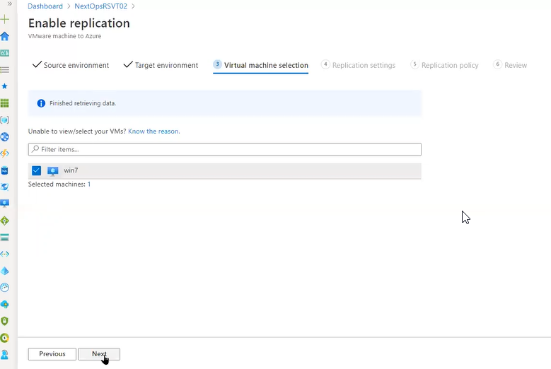

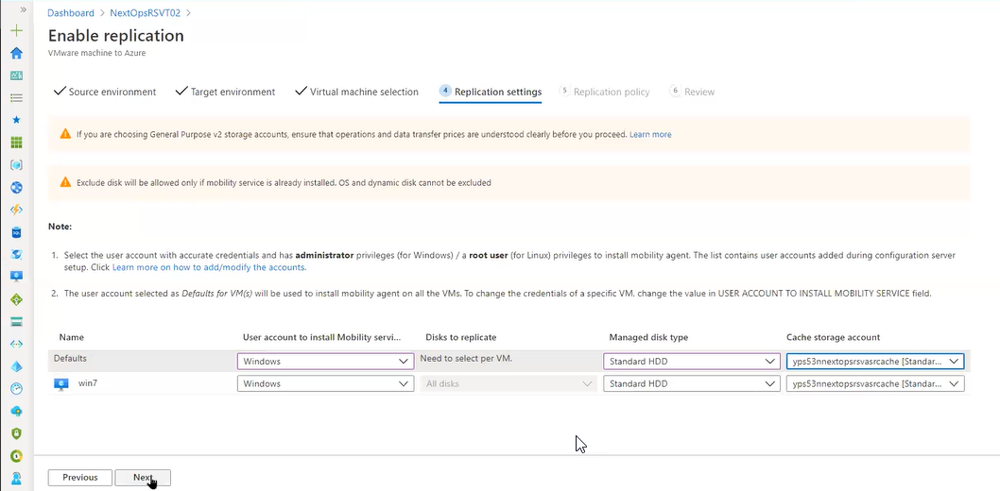

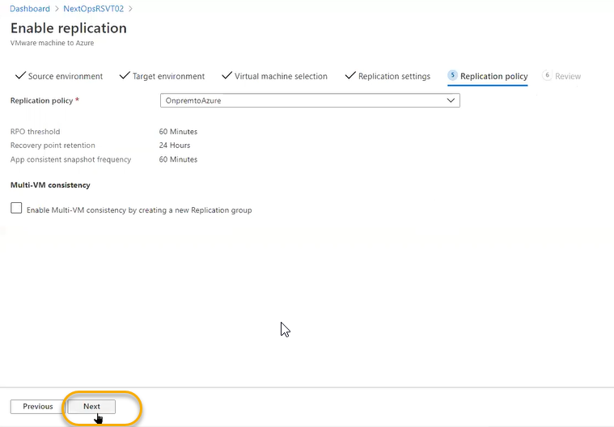

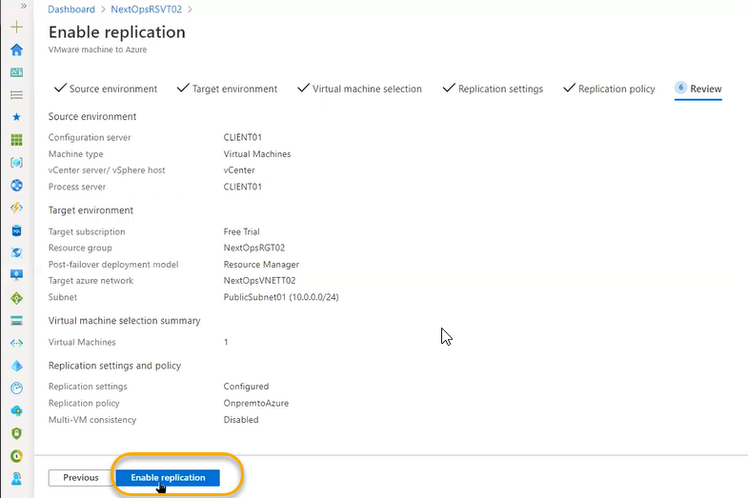

It will take time to replicate the process

Some time we will see the error so at that time we can click on the Disable protection and again after this process click on the Reprotect

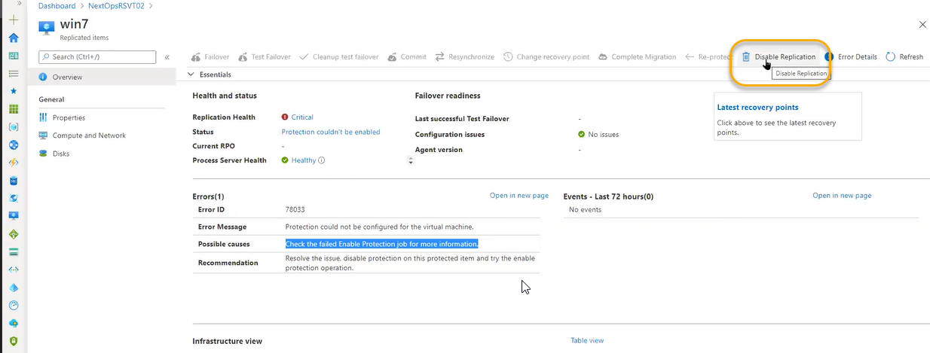

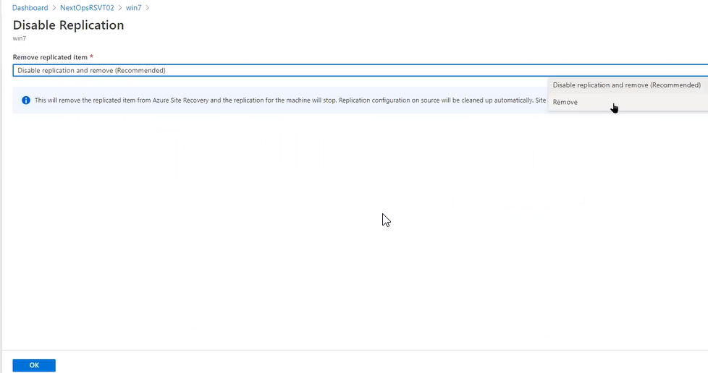

From Vmware environment we are accessing from configuration management in the configuration server accessing from ESX to VMware connection we need to enter the below credentials above the Esx machine Windows machine is running. For connecting the VM also we need the credentials

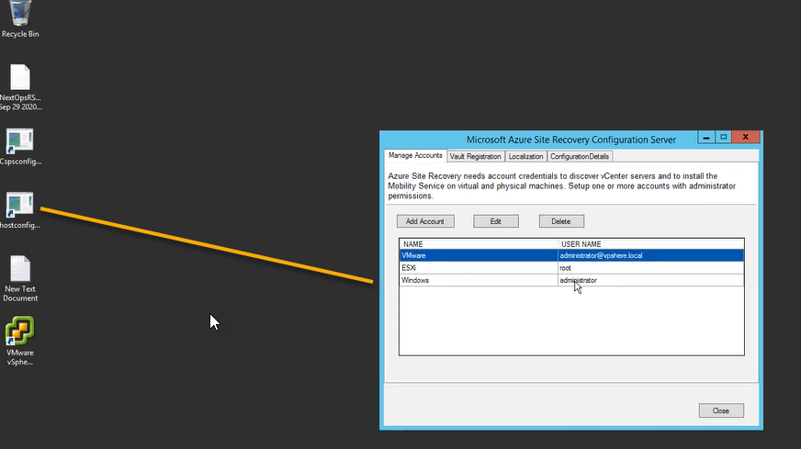

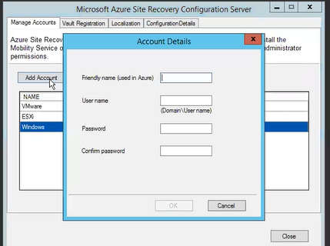

That will upload to azure machine

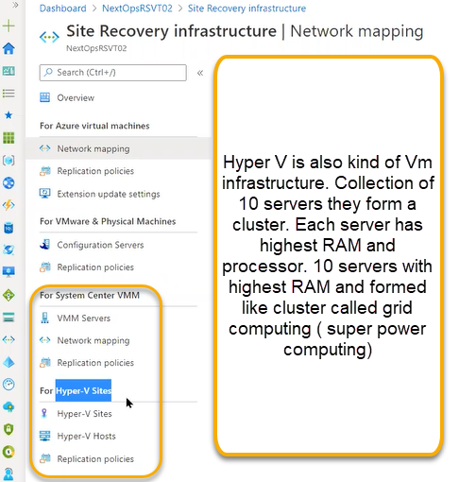

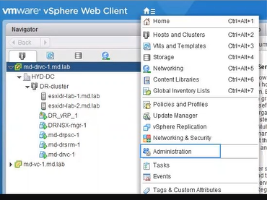

In the hyper v each server is independent and no concept of cluster like vm ware and above the servers the VM will be runned

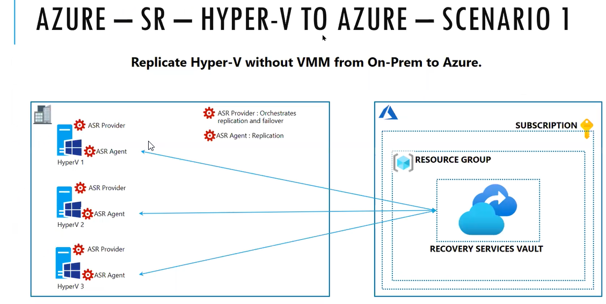

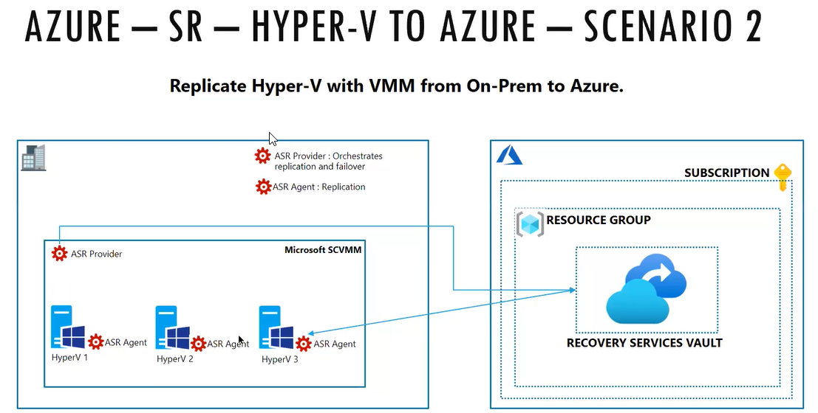

For the VMM if you give provider and agent. Compared to VM Ware hyper V installation is easy because source and destination is hyper v

Recovery Plans

Backup Jobs and site Recovery Jobs used to analysis if we have any failed jobs

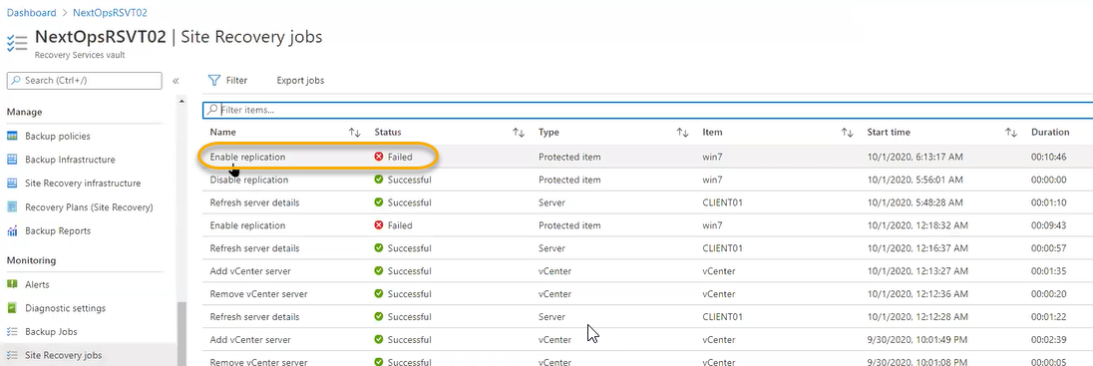

Click on the Restart then the Jobs will start processing

